*Topic 1: Basic Linux Commands
- Pwd ~ Display the current working directory
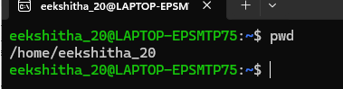

- Clear ~ clear the terminal screen
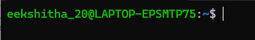

- History ~ displays previously executed commands
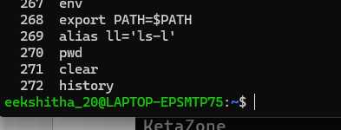

- Whoami ~ display the current logged-in username
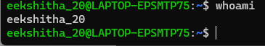

- Date ~ display the current system date and time
0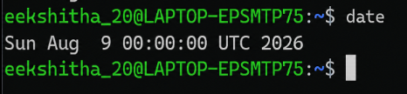

- Hostname ~ Display the system hostname
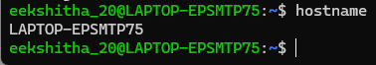

- Uname -a ~ Display operating system operation

- Exit ~ exit the terminal
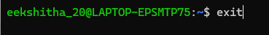

TOPIC 2 ~ DIRECTORY MANAGEMENT

- Ls ~ list files and directories

- Ls -a ~ display detailed file information
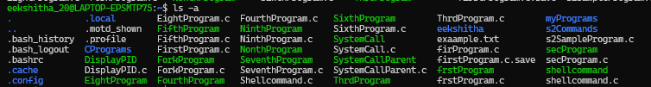

- Cd ~ change the current directory
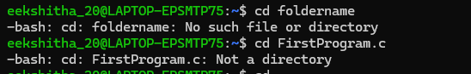

- Cd ..~ move to parent directory
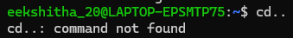
- mkdir ~ create a new directory
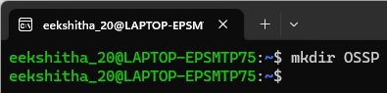

- rmdir ~ remove a directory
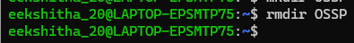

- find FileName.c ~ search for files and directories
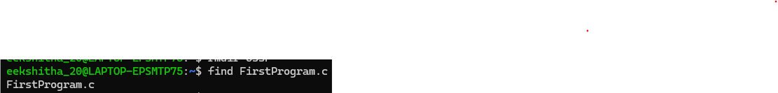

- locate ~ Quickly locate files

9.ls -l
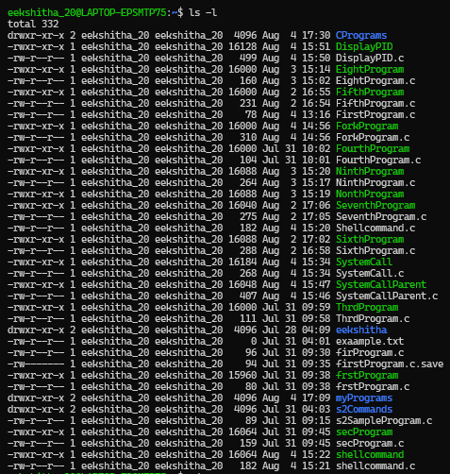

3.FILE MANAGEMENT

1.touch ~ Create new empty file
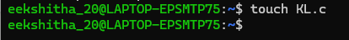

2. cat ~ display file contents
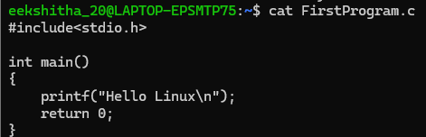

3. cp ~ copy files or directories

4. mv ~ move or rename files

5. rm ~ remove file
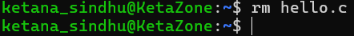

6. head ~ display first lines of a file
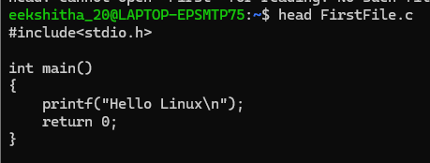

7. tail ~ display last lines of the file
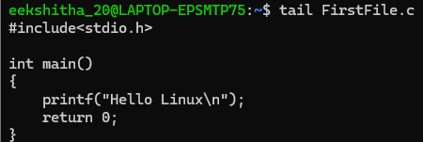

8.more ~ view a file page by page
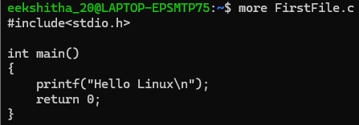

9.less ~ Scroll through a file
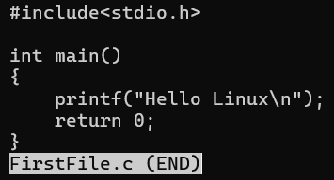

10.wc ~ count lines, words and characters
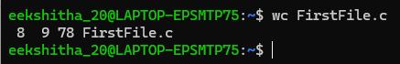

11.diff ~ compare two files
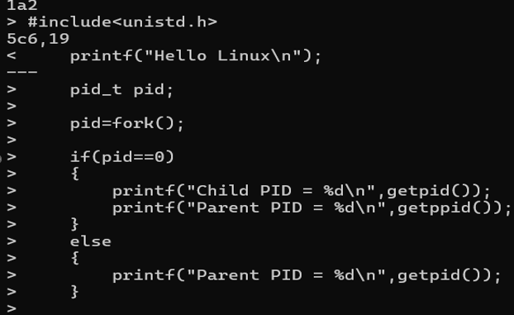

12.sort ~ sort file contents
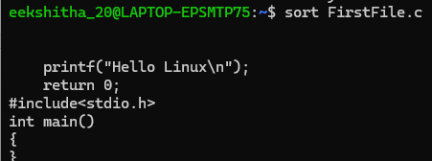

13.uniq ~ remove duplicate files
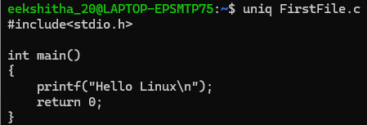
14.grep ~ search for text inside a file
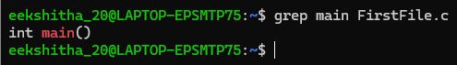

4. TOPIC ~ FILE EDITING
1.nano ~ create or edit a file
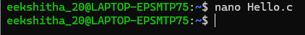
2. vi ~ edit a file using vim editor
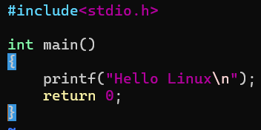

5. C PROGRAM COMPILATION AND EXECUTION

- gcc ~ compile a C program
- . /program ~ Execute the compiled program
- which ~ Locate the executable of a command
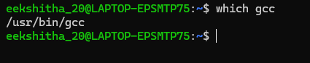
- whereis ~ Locate binary, source and manual pages
- man ~ display manual pages
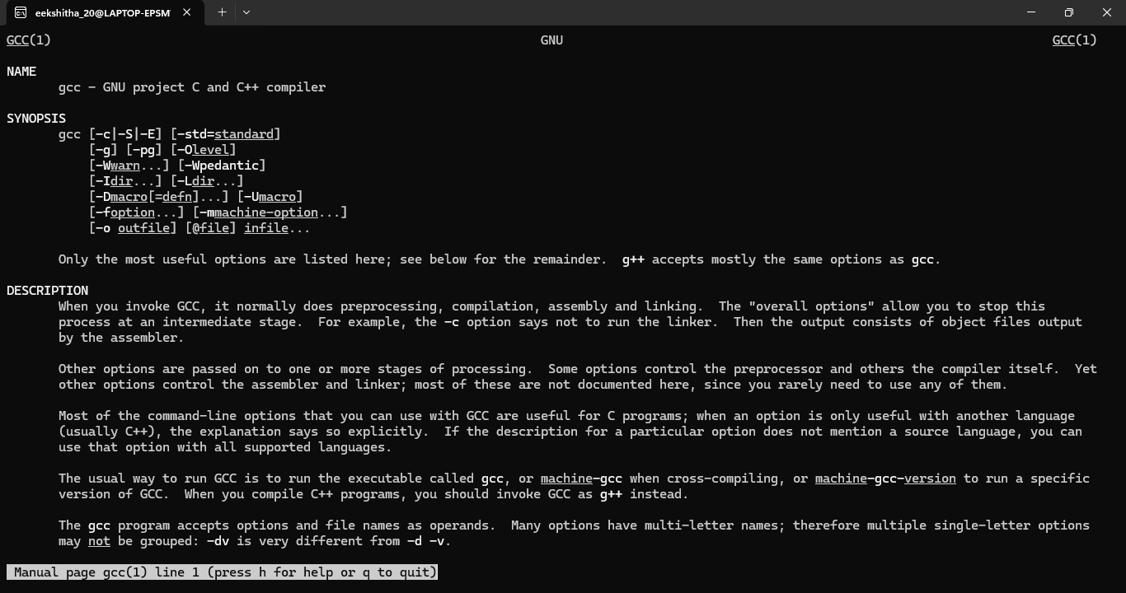

6.PROCESS MANAGEMENT

1. ps ~ display running processes
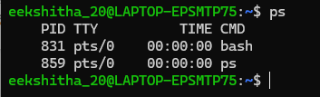

2. ps -ef ~ display all running processes
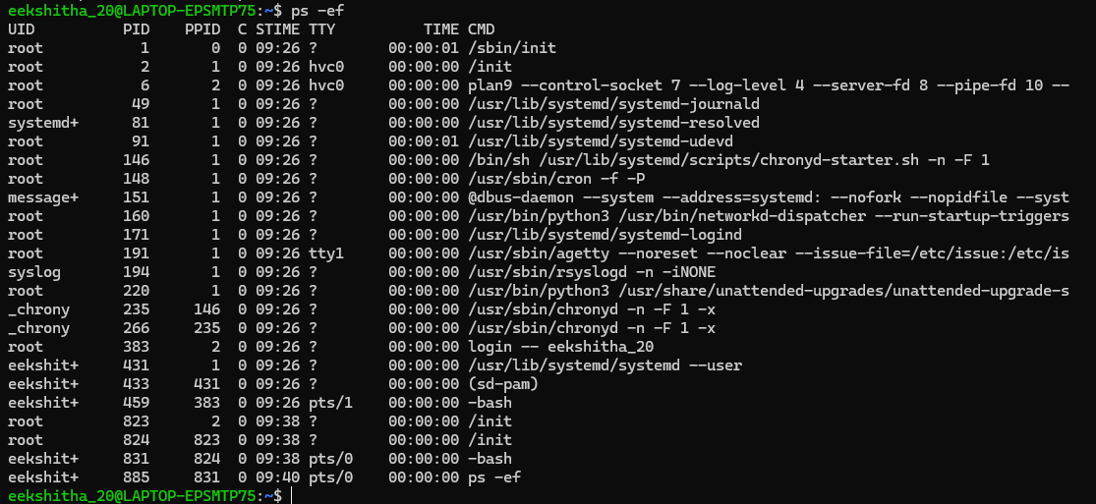

3. top ~ monitor running processes
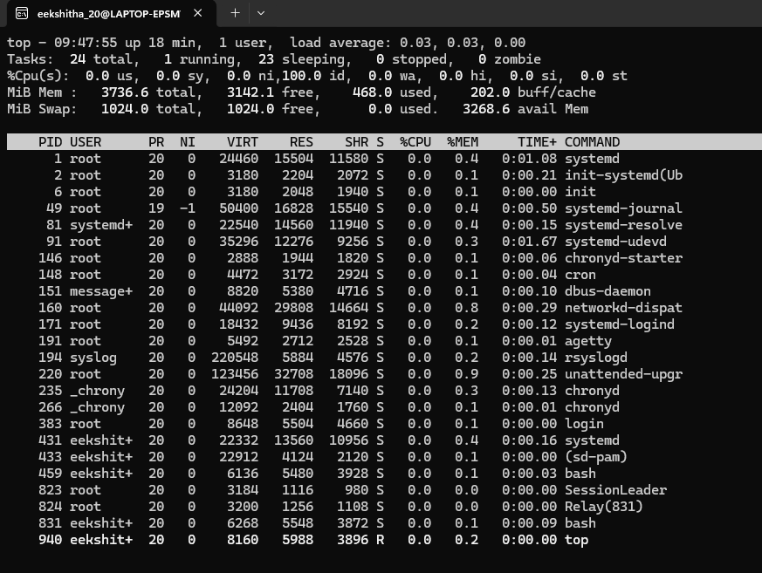

4. kill ~ terminate a process
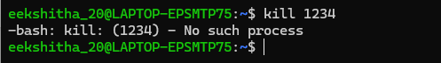

5.kill -9 ~ Forcefully terminate a process

7.JOB CONTROL

1. jobs ~ Display background jobs
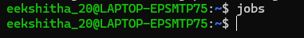

2. bg ~ Resume a job in the background
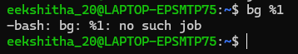

3.fg ~ Bring a job to the foreground
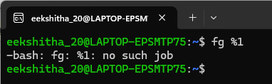

4.& - Run a process in the background
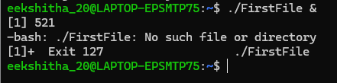

8.FILE PERMISSIONS AND LINKS

1. chmod ~ Change file permissions
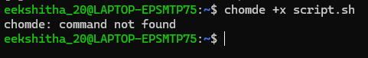

2. chmod 755 ~ Set rad, write and execute permissions
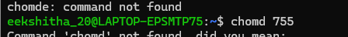

3.ln ~ create a hard link

4.ln -s ~ create a symbolic link
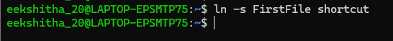

- DISK AND MEMORY INFORMATION

- df -h ~ display disk space usage
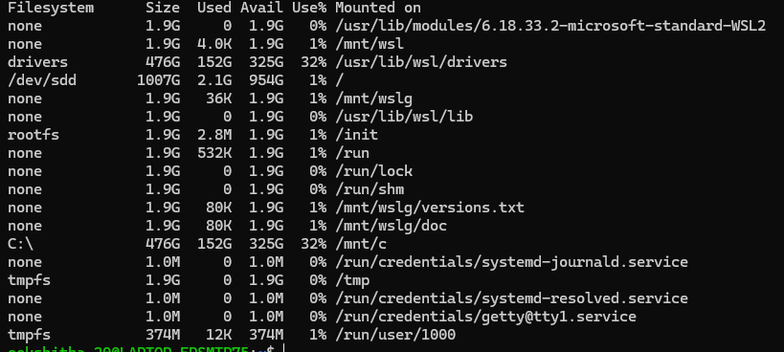

- du -sh ~ display directory size
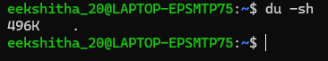

- free -h ~ display memory usage (Linux)
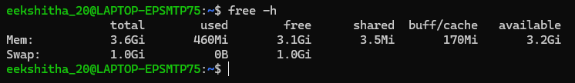

10.USER AND ENVIRONMENT MANAGEMENT

1.id ~ display user and group IDs

2.env ~ display environment variables
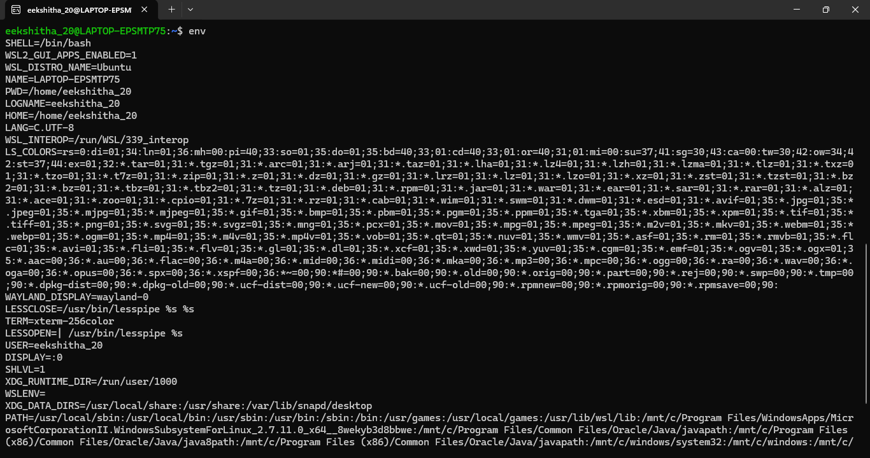

3.export ~ Set an environment variable
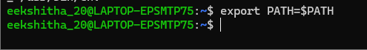

- alias ~ Create a command shortcut
